Oregon Institute of Technology

CST 315 – Midterm

I have neither given nor received help on this exam.

___Chris Thomas_________________________

Date: __11/21/2022____________

1. In the circuit below determine the Voltage across each of the three resistors, the current through each of the resistors, the power dissipated in each of the resistors, the total current provided by the battery, and the power (in Watts) supplied by the battery.

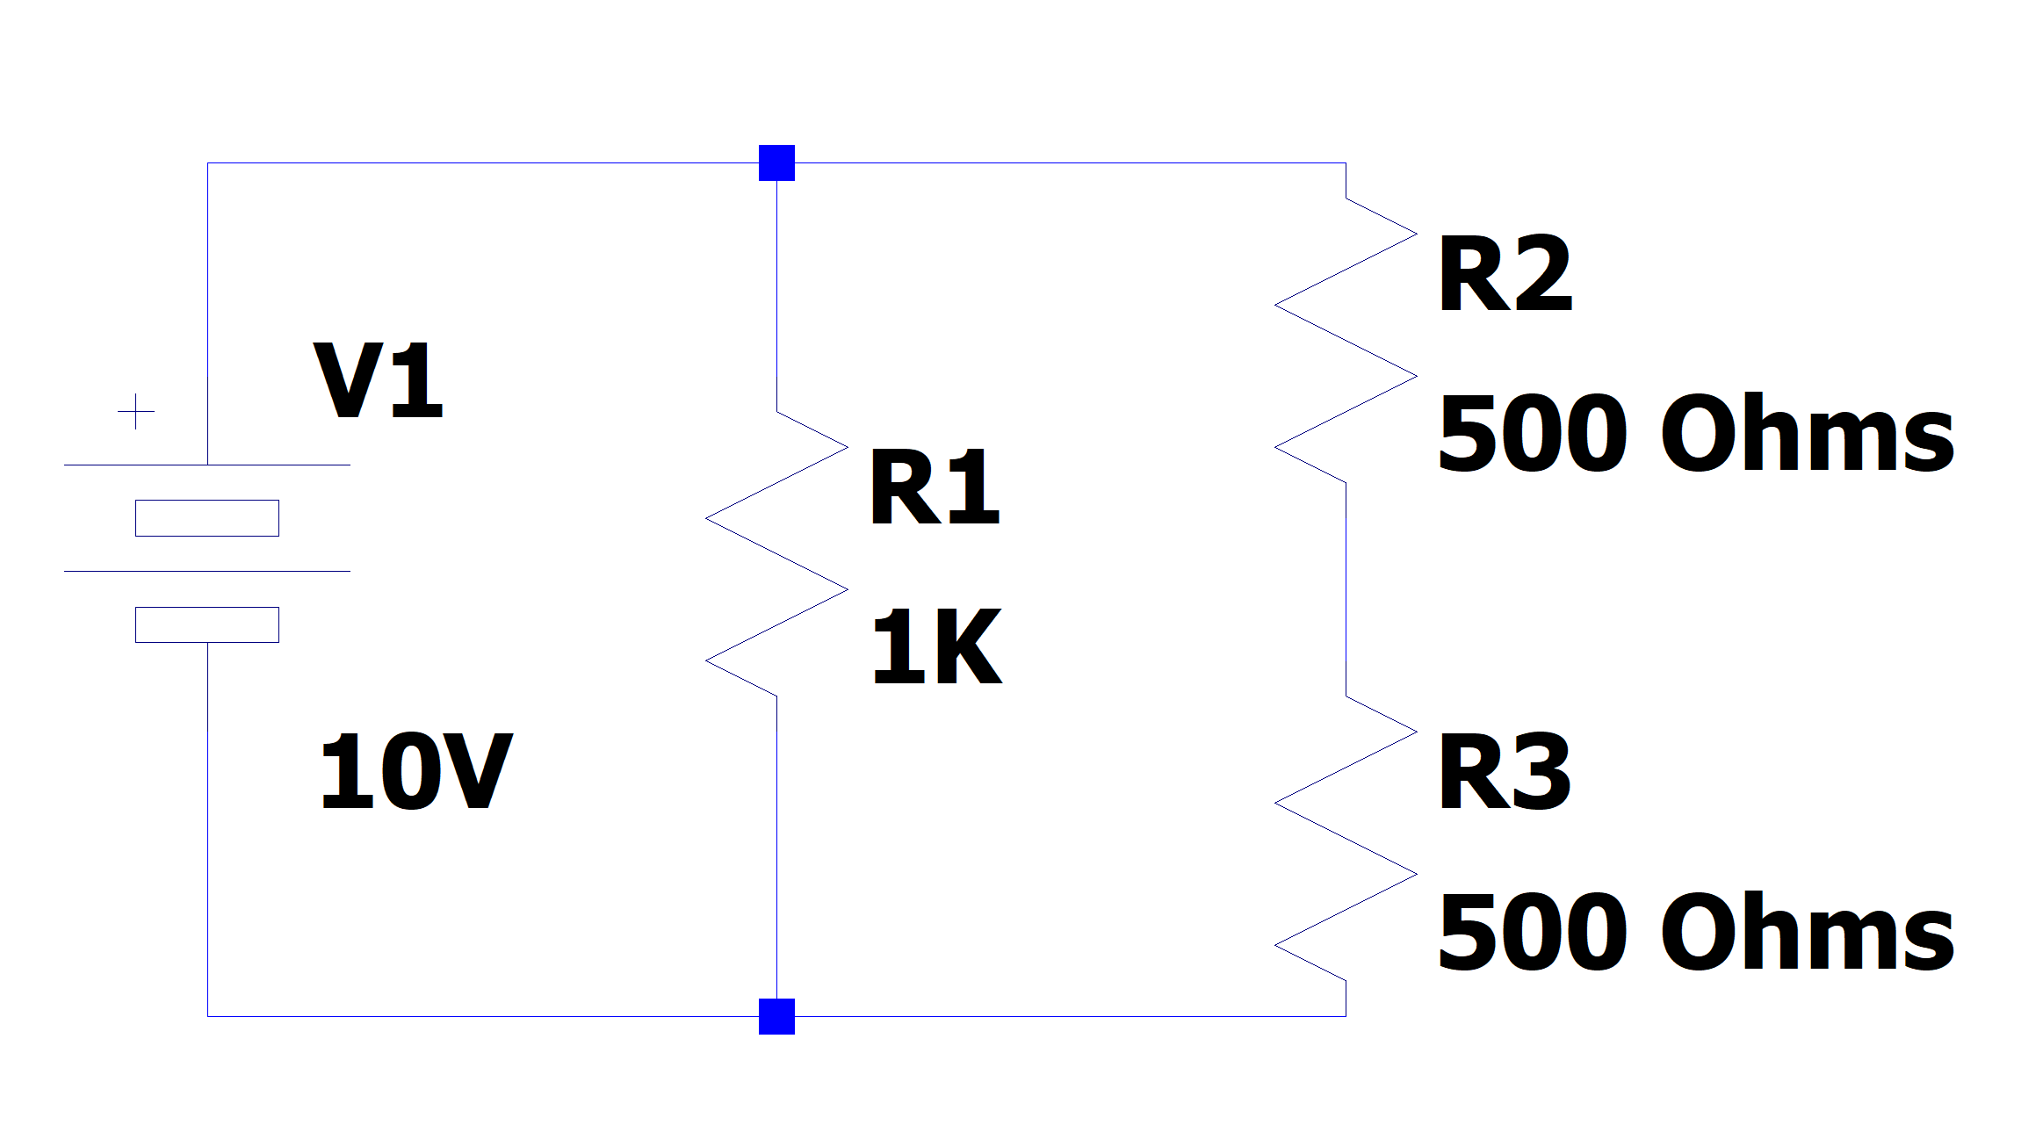

R1 = 10V

R2 = 5V

R3 = 5V

I1 = 10mA

I2 = 10mA

I3 = 10mA

P1 = 100mW

P2 = 50mW

P3 = 50mW

Ib = 20mA

Pb = 200mW

1. What is the magnitude of the voltage gain of the circuit below? What is the magnitude of the voltage gain expressed in decibels with respect to 1 Volt? If Vin = 0.25 Volts DC what does Vout equal (be careful of voltage sign)? If Vin = 2 Volts DC what does Vout equal?

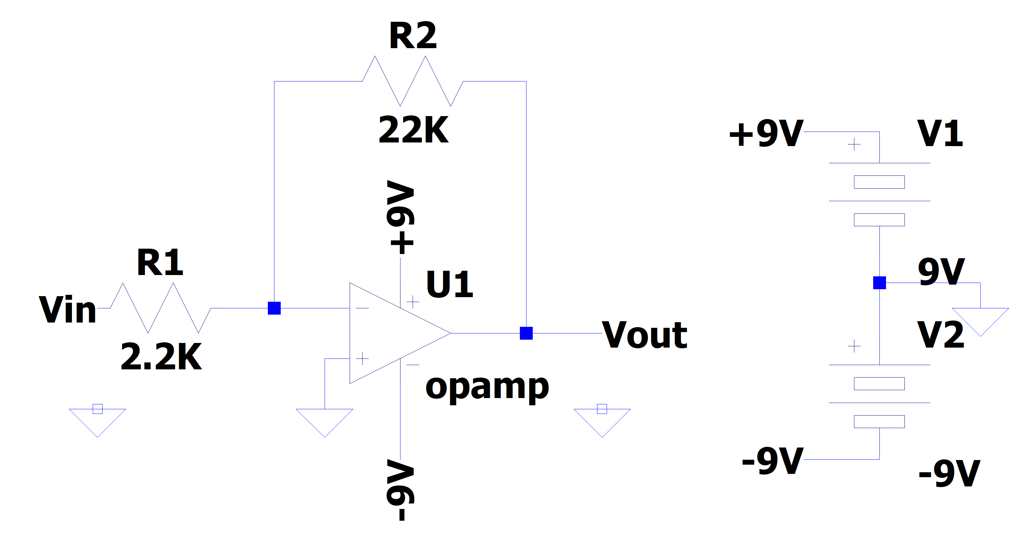

Gain = 10

dB = 20

Vout = -2.5V

Vout = -9V